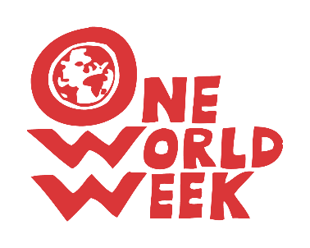
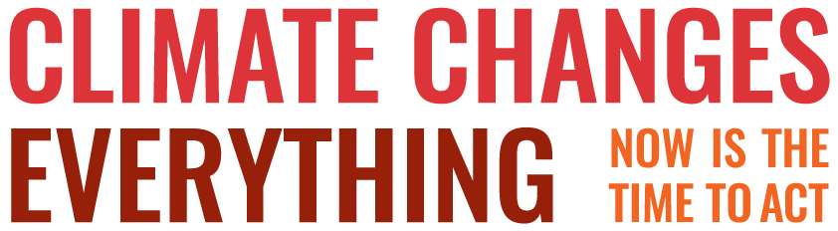

USEFUL WEBSITES FOR FAITH GROUPS
(These include campaigns, activities and resources for worship)

CAFOD
The Catholic Agency for Overseas Development has lots of great resources including be a Zero Hero and Our Common Home plus more for schools and youth groups
www.cafod.org.uk/Campaign/Climate/Climate-Change

Christian Aid
Lots of ideas and resources too, especially right now on divesting from fossil fuels.
www.christianaid.org.uk/campaigns/climate-change-campaign

Earthday
Ideas, campaigns and resources for various faiths
https://www.earthday.org/campaigns/campaign-for-communities/communities-of-faith/

Eco Church
A Rocha has an eco-church project which offers a free online survey and supporting resources It covers looking after buildings and land; engaging with the local community and in global campaigns, and in the personal lifestyles of the congregation.
https://ecochurch.arocha.org.uk/

Eco Synagogue
Provides a practical and simple roadmap for synagogues. Eco Synagogue is a cross-denominational project with synagogues from each of the movements invited to participate. Eco Synagogue was developed in partnership with A Rocha, founders of Eco Church, and launched in January 2018.
https://ecosynagogue.org/

Faith for the Climate
- exists to encourage, inspire and equip faith communities in their work on climate change. Links to:
- examples of faith group activities https://www.faithfortheclimate.org.uk/Building-Capacity
- websites which cater for each of the main Faiths’ engagement in environmental issues (https://www.faithfortheclimate.org.uk/Faith-Resources )

https://www.faithfortheclimate.org.uk/index.html

Green Christian
Lots of ideas for action, and worship resources
www.Greenchristian.org.uk

GreenFaith
An interfaith coalition for the environment that works with houses of worship, religious schools, and people of all faiths to help them become better environmental stewards.

This site is based in the USA and some of its sections relate specifically to activities (some of which could be models for wider adoption). Of particular value to OWW organisers are the sections on:
- Religious teachings relating to the environment: https://greenfaith.org/greenfaith_religious_teachings
- Eco-prayers and rituals
https://greenfaith.org/ecospirituality

NB – if planning interfaith worship do look at this guidance: “Interfaith Worship or Act of Reflection and Commitment”

Hope for the Future
A Christian organisation which trains people in communicating with MPs
http://www.hftf.org.uk/

Islamic Foundation for Ecology and Environmental Sciences (IFEES) is a UK registered charity operating internationally, through programmes designed to increase knowledge and awareness, alleviate poverty, combat climate change and deal with other major environmental issues. See the Islamic Declaration on Climate Change here and the Muslim Green Guide to Reducing Climate Change here
www.ifees.org.uk/

One Earth Sangra – a Buddhist perspective
https://oneearthsangha.org/

Operation Noah
Working with the churches to inspire action on climate change, Operation Noah has resources, Bible studies and a divestment campaign.
www.operationnoah.org

Pray and Fast for the Climate
https://prayandfastfortheclimate.org.uk/

Quaker Peace and Social Justice
Lots of action and ideas
https://www.quaker.org.uk/our-work/sustainability/climate-justice-1

Tearfund
Campaigning and fund-raising especially on clean energy
www.tearfund.org/en/about_us/what_we_do_and_where/issues/climate_change/

Wild Christian
A new site from A Rocha – a monthly programme connecting faith, nature and climate.
www.arocha.org.uk/wildchristian

Updated 02-08-2019

